PROJECT OUTLINE
BEng

Name: Goh Zheng Long

Supervisor: Daniel Lim

Page limit: 10 pages excluding appendices

Project Title in
Arial Bold 21pt

Date

INTRODUCTION

Project justification

Background
Tunnels are an important part of infrastructure that support transportation, water systems, and utilities. They connect places, make travel and services faster and more efficient. After some time, tunnels face problems like cracks, water leaks, and damage from use and even natural forces like earthquakes on extreme cases. If these issues are not found and fixed early, they can cause serious problems such as collapses, costly repairs, and even danger to people’s lives
In the past, tunnel inspections are done manually. This means experts go into tunnels and look for problems with their eyes or use basic tools. While this works in some cases, it has several challenges. Manual inspections are slow, require a lot of work, and is dangerous, especially in hard-to-reach areas. Additionally, people can make mistakes, especially in dim light or when they can’t see hidden defects
Technology such as artificial intelligence (AI), robotics, and computer vision can help solve these problems. By combining these technologies, we can create a robot that can detect tunnel defects quickly, accurately, and safely. This would improve how inspections are done and reduce risks

Motivation
The main reasons for creating an AI robot for tunnel defect detection are:
- Improving Safety: Detect tunnel problems early can prevent accidents, tunnel collapses, or service disruptions, this helps protect the people and the infrastructure
- Saving Time and Costs: Manual inspections take a lot of time and can disrupt tunnel operations. A robot can do inspections faster and saving time and reducing costs
- Better Accuracy: AI can detect even small defects, like tiny cracks or water leaks, which human inspectors might miss. This ensures a more thorough inspection
- Reaching Dangerous Areas: Some parts of tunnels, like underwater sections or places with harmful gases, are not safe for humans. A robot can safely inspect these areas without putting people at risk
- Planning Repairs: An AI system can track tunnel conditions over time and predict when repairs will be needed. This helps tunnel managers plan maintenance before the problems get worse
- Flexibility for Different Tunnels: The robot can be designed to work in all types of tunnels, such as highways, railways, or utility tunnels, making it useful in many industries
This project aims to create a smart robot that uses cameras, sensors, and AI to find and classify tunnel defects. The robot will also provide reports to help engineers make quick decisions. It will be small and mobile, so it can move through tunnels easily
This robot will make tunnel inspections safer, faster, and more reliable. It will reduce costs, prevent major problems, and ensure tunnels stay safe for people to use. By using AI and robotics, this solution will modernize how tunnels are maintained and managed
An AI-powered tunnel inspection robot can solve many problems with current methods. It can improve the safety, the cut costs, and provide better data for maintenance works. This project will contribute to stronger and safer infrastructure while reducing risks and saving resource

Project Aims and Objectives

Project Aim
The aim of this project is to design and develop an AI-powered autonomous robot capable of detecting, classifying, and reporting structural defects in tunnels. The robot will utilize advanced technologies such as artificial intelligence, computer vision, and robotics to improve the efficiency, accuracy, and safety of tunnel inspections

Project Objectives
- Develop an AI-Powered Defect Detection System
  - Create an AI model capable of analyzing tunnel surfaces to identify common structural defects such as cracks, spalling, water seepage, and deformations
  - Ensure the model achieves high accuracy and reliability in defect detection and classification under various environmental conditions
- Implement Real-Time Data Processing and Reporting
  - Develop software that processes data captured by the robot in real-time, allowing immediate identification and reporting of defects
  - Create a user-friendly interface for displaying inspection results, including visual reports and actionable insights
- Enable Autonomous Navigation
  - Program the robot to navigate autonomously through tunnels, avoiding obstacles and covering the entire inspection area
  - Implement algorithms for path planning and localization to ensure thorough and efficient inspection.
- Test and Validate the System in Simulated and Real-World Conditions
  - Conduct extensive testing in controlled environments to refine the robot’s defect detection capabilities and navigation performance
  - Validate the system by deploying it in real-world tunnel scenarios, ensuring it meets industry standards for accuracy and reliability
- Optimize the System
  - Design the robot and software to be adaptable for use in various tunnel types, including transportation, utility, and underwater tunnels
  - Ensure the system is scalable to allow for future enhancements and integration with other infrastructure monitoring technologies

Methodology

Research and Requirement Analysis
- Literature Review: Study existing tunnel inspection methods, defect detection technologies, and robotic systems. Identify gaps and limitations in current practices
- Requirement Gathering: Define the functional and technical requirements for the robot, including defect types to be detected, tunnel environments, mobility needs, and safety considerations
- Technology Selection: Select suitable technologies, including hardware (sensors, cameras, microcontrollers) and software frameworks (AI models, robotics control algorithms)

AI Model Development
- Data Collection: Gather a dataset of tunnel defect images. Data will include images from different tunnel types and environmental conditions
- Data Preprocessing: Clean and annotate the dataset to ensure high-quality inputs for training the AI model.
- Model Training: Develop a machine learning or deep learning model using frameworks like TensorFlow or PyTorch. Train the model to detect and classify tunnel defects.
- Model Validation: Test the model’s accuracy using a validation dataset. Refine the model to minimize false positives and false negatives.

Software Development
- Navigation Algorithms: Develop autonomous navigation algorithms using techniques like SLAM to allow the robot to move through tunnels without external assistance
- Real-Time Processing: Integrate the AI defect detection model into the robot’s onboard system to process data in real time
- Reporting Interface: Design a simple and intuitive interface for engineers to view inspection results, including defect locations, classifications, and images

RESOURCE ANALYSIS

Software Tools
- AI Development Tools
  - TensorFlow or PyTorch: Tools to build and train the AI system that will identify tunnel defects like cracks or leaks
  - OpenCV: Used for processing images and analyzing the visuals captured by the robot
  - LabelImg or CVAT: Programs for marking or tagging defect images to help train the AI
- Robot Control System
  - Robot Operating System (ROS): A system that helps control the robot’s movement, process sensor data, and connect all the parts of the robot’s software
- Testing and Simulation Tools
  - Webots: A virtual environment where we can test the robot's movements and ability to find defects before trying it out in real tunnels
  - MATLAB or Simulink: Tools for designing and testing how the robot’s systems work together
  - RViz: A tool that shows live data from the robot, like maps and sensor readings, so we can check how it’s performing
- Programming and Development
  - Python: Used for writing the AI and processing data from sensors
  - Visual Studio Code: A simple software where all the coding is done
- Data and Reports
  - Matplotlib or Tableau: For creating graphs or charts to show the results of defect detection
  - Flask or Django: Tools for building a user-friendly website or app to show inspection reports
- Collaboration Tools
  - Git/GitHub: For keeping track of code changes and sharing work with team members

Testing Environments
- Virtual Testing
  - Use tools like Webots to create a digital version of a tunnel where the robot can practice finding defects. This is like a video game environment that simulates real-world challenges
- Mock Testing Area
  - Build a small tunnel setup with known defects to test the robot in a controlled space. This helps us see if the robot works as planned before moving to real tunnels
  - Add challenges like dim lighting, uneven floors, or water to mimic real tunnel conditions

PROJECT PLAN

Project Work Description
- Research and Planning
    - Study how tunnel inspections are done now and identify the main challenges.
    - Decide on the features the system needs and choose the right tools and technologies (like AI software and sensors)
  - Estimated Time: 1 week
  - Risks:
    - Not enough reliable information on tunnel defects.
    - Picking tools that don’t fully meet the project’s needs
- Dataset Preparation and AI Model Development
    - Gather pictures of tunnel defects (e.g., cracks, leaks) and label them for training the AI
    - Build and test an AI model to detect and classify these defects
    - Fine-tune the AI to make it fast and accurate
  - Estimated Time: 1 week
  - Risks:
    - Limited access to good-quality images for training the AI
    - The AI might struggle to detect certain defects accurately
- Software Development
    - Create the software to guide the system’s movements (autonomous navigation)
    - Connect the AI model to the system so it can process and report defects in real-time
    - Build a simple interface to display results (like maps and photos of defects).
  - Estimated Time: 2 weeks
  - Risks:
    - Bugs or glitches in the software affecting navigation or defect detection.
    - Problems integrating all the system parts
- Testing in Simulated and Real Tunnels
    - First, test the system in a virtual environment to check if it detects defects and navigates well
    - Next, test it in controlled settings, like a mock tunnel, to simulate real conditions
    - Finally, take it to real tunnels to confirm it works effectively in real-world environments (not recommended and probably will not be allowed to)
  - Estimated Time: 2 weeks
  - Risks:
    - The system might miss defects under real-world conditions
    - Navigation challenges in tunnels with unexpected obstacles or poor lighting
- Optimization and Improvements
    - Review the test results to see what can be improved.
    - Make changes to the AI, navigation system, or interface to ensure everything runs smoothly
  - Estimated Time: 1 week
  - Risks:
    - Time may be tight for fixing all issues found during testing.
    - New challenges might arise during optimization
- Documentation and Final Delivery
    - Write clear guides on how the system works, including technical details and user instructions
    - Deliver a complete and functional prototype for inspection teams to use
  - Estimated Time: 2 weeks
  - Risks:
    - Running out of time to prepare thorough documentation
    - The final system might still need minor adjustments

Risks to Project Success
Technical Challenges:
The AI might not perform as expected, or software bugs could slow progress
Limited Resources:
Delays in accessing datasets, tools, or real tunnels for testing
Tight Deadlines:
Some tasks, especially testing and optimization, might take longer than planned
Environmental Factors:
Real tunnels might have unpredictable conditions, such as low visibility or unexpected obstacles

REFERENCES/bibliography
Here are some references and projects that also tackle the theme of AI Tunnel Defects Detection robot:
ROBO-SPECT Project. (2017). Autonomous Robotic Inspection and Maintenance for Tunnel Infrastructure. Available at: Springer [Accessed 5 December 2024]
Innovation Hub Hong Kong. (n.d.). 3S Tunnel Defect Inspector. Available at: Innovation Hub HK [Accessed 5 December 2024]
ArXiv. (2023). Autonomous UAV Inspection Framework for Tunnel Construction. Available at: arXiv [Accessed 5 December 2024]
Sustainability. (2023). Deep Learning-Based Framework for Tunnel Defect Detection. Available at: MDPI [Accessed 5 December 2024]
ANYbotics. (n.d.). ANYmal: Autonomous Robot for Tunnel and Industrial Inspection. Available at: ANYbotics [Accessed 5 December 2024]

APPENDIX A: Gantt Chart

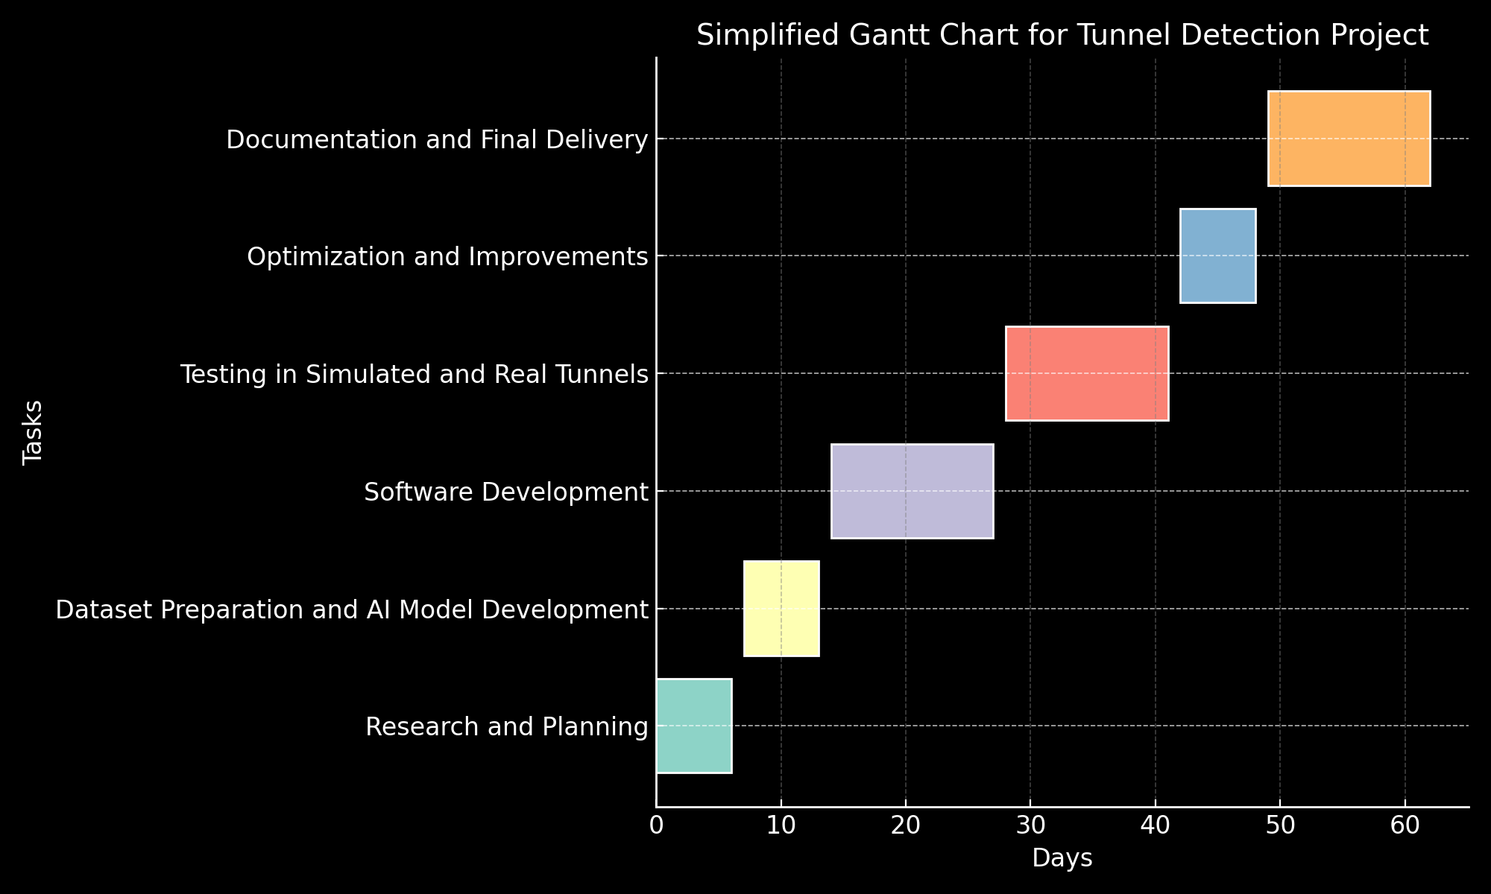

APPENDIX B: Project Resources Checklist

Please PRINT all information CLEARLY
Student’s Name: | Goh Zheng Long
SRN: | 346DGTZT
Project Title: | Tunnel Navigation Robot
Supervisor’s Name: | Daniel Lim
Date: | 5th December 2024

Please enter below your BEST ESTIMATES for the information requested. You will not be penalised for small errors and later genuine changes - only for not bothering!

1 | Will materials or components need to be ordered? | Yes | No
2 | Will you be designing a PCB or drawing which will require manufacture during your project? (Note that this should only be contemplated where absolutely necessary for the success of the project!) | Yes | No
3 | Will PCB or drawing assemblies already designed and manufactured within the School be required? Please specify: | Yes | No
4 | Will a PC be required for work other than for report writing? | Yes | No
5 | If the answer to 4 is Yes, will you require any special hardware installed/attached (e.g., PROM emulation, USB interface). Please specify: | Yes | No
6 | Will you require specific software, other than word processing? (Please specify): | Yes | No
7 | Will your project require technical staff to make items requiring workshop facilities? | Yes | No
8 | If the answer to 7 is Yes, which of the following workshop activities will be required (please circle):  Drilling, Sheet metal forming, Lathe work, Milling, Other (Please specify)
9 | Are there other resources required, not covered above? (Please specify): | Yes | No

APPENDIX C: Project Risk, Ethics and Threat Assessment Checklist

- Please enter below your BEST ESTIMATES for the information requested.

1 | Is your project likely to involve either deliberate, or possible accidental use or contact with:  Voltages above 30V  High currents at low voltage (e.g., lead acid batteries)  Rotating machines  High/Low temperatures  Hazardous fluids or gases  Radiation emitting equipment  Chemicals or Substance Hazardous to Health | Yes | No
2 | Will your project involve attaching electrodes to yourself or someone else in such a way as to produce low impedance contact? | Yes | No
3 | If the answer to 1 and/or 2 is Yes, has an assessment of the risk in the planned procedure been carried out? | Yes | No
4 | If the answer to 3 is Yes, does the analysis show an acceptable level of risk? | Yes | No
5 | Are any substances classified as being 'Hazardous to Health' likely to be used in the course of your work? | Yes | No
6 | Are any flammable substances likely to be used in the course of your work? (e.g., volatile cleaning agents, paint, etc.) | Yes | No
7 | Are there any other aspects of your projected work which might impose a danger to yourself or to others? (Please specify): | Yes | No
- Notes: If the answer to any of these questions is YES, you must complete a School of Physics, Engineering and Computer Science risk assessment. This should be approved and signed by your supervisor prior to submission. The risk assessment should also be submitted as an appendix in your report.

Ethical Issues
8 | Will your work involve human subjects, e.g., survey, interview, experiment, etc. This includes friends and family. | Yes | No

- If the answers to either of questions 2 or 8 are YES, the proposed work must be submitted for approval to the Ethics Committee before work proceeds. Consult your supervisor and review the UH Ethics Approval Canvas Module for information on the procedures.
- Please ensure your project does not use animals for experimentation or other testing/data gathering. These require a different set of approval procedures which will be addressed on a case-by-case basis. If you believe that you MUST use animals in your project, please contact your Supervisor to discuss this necessity.

APPENDIX D: Industrial Projects
Industrially based project proposals may be submitted by industrialists, part-time students and sandwich students returning from their year in industry. For these projects, an industrial guarantor is required.
Industry based projects are particularly important for part-time students who do not have official timetabled project sessions at the University and are therefore expected to undertake the bulk of their project at their place of work. Part-time students in their second year are encouraged to make early investigations into the possibility of undertaking a project at their place of employment.
Industrial guarantor's agreement:
This form is relevant to those projects that are being undertaken in industry. For an industrial project to run, this form must be completed and signed by the industrial guarantor and the student.
The role of the industrial guarantor:
All final year students are required to undertake an engineering project as part of their degree. Some students, particularly those undertaking a part-time course while working in industry, choose to undertake projects in an industrial environment. For this group of students, each will have an academic Supervisor at the University and an industrial guarantor at the workplace.
The role of the industrial guarantor is to provide the student with technical support in the workplace, and to guarantee that the student has undertaken the work as reported and without undue assistance. The support will nominally require 10-15 hours per week for the duration of the project for part time students.
Part-time students entering their final year who have not arranged a project and guarantor must do so by the start of that academic session, at the latest.
Agreement:
Before completing this section of the agreement, the prospective industrial guarantor should discuss the project with the student and broadly understand the terms of reference of the project and the student's role in the project.
The letter on, company notepaper, should be posted to the School Project Tutor and should contain the wording given below before the project work is started.

I (industrial guarantor’s name printed) ____________________________________ agree to my role as industrial guarantor for the (student's name printed) _____________________________________________________________________.
Signed (guarantor): |  | Date:
Contact address & telephone number of guarantor:
Signed (student): |  | Date: | 5th December 2024
Contact address & telephone number of student: | +65 96434676

